**WEEK 4 ASSIGNMENT (DIGITAL NURTURE 4.0 JAVA FSE)**

**NAME: JEYAKUMAR R**

**SUPERSET ID: 6396631  
   
 Exercise 1 : Create a Spring Web Project Using Maven**

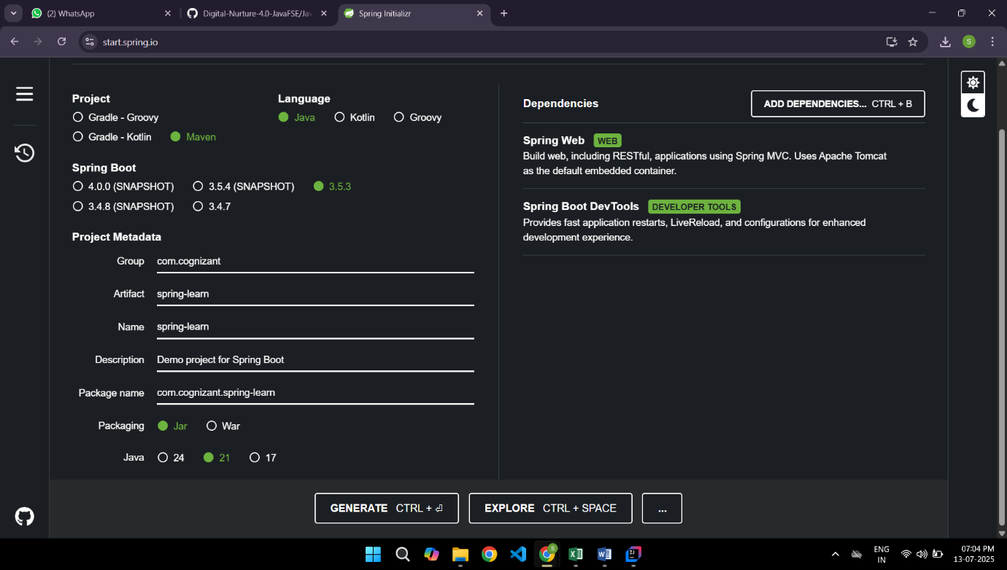

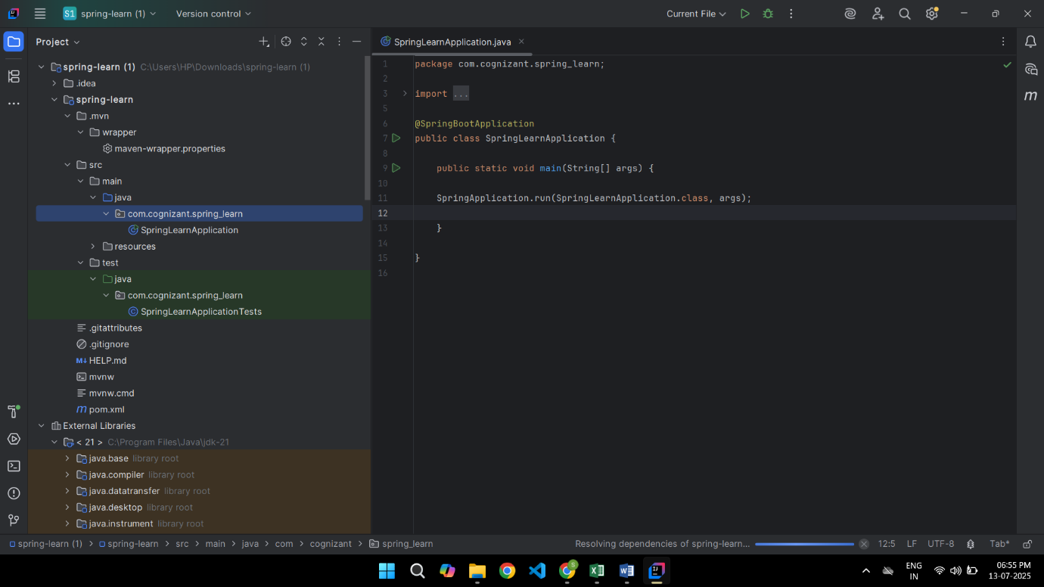

**OUTPUT:**

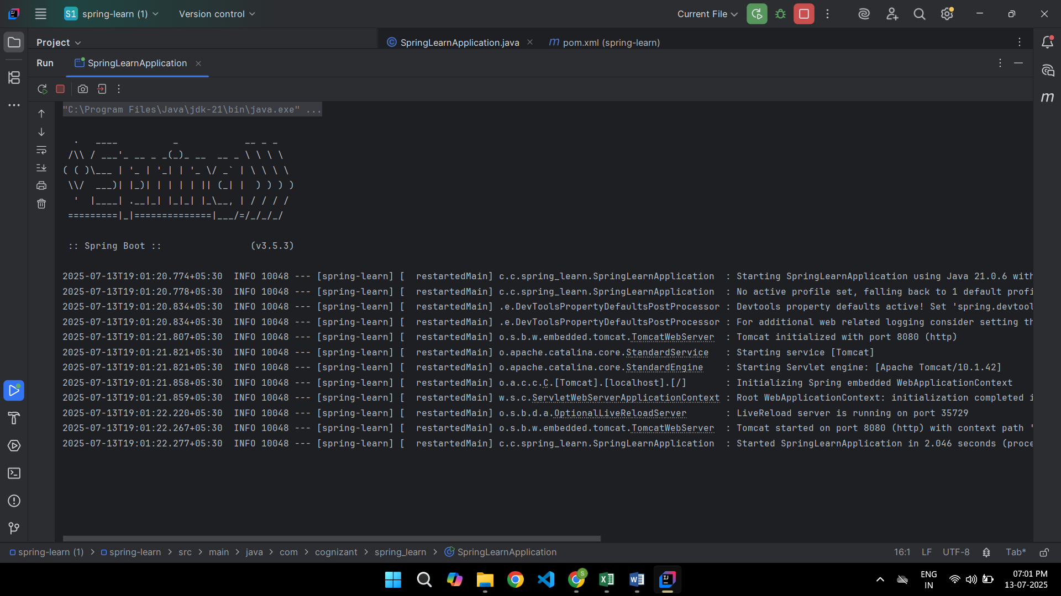

**Exercise 3: REST –GET Country Based on Country Code**

**CountryController.java**

package com.cognizant.spring_learn.Controller;

import com.cognizant.spring_learn.model.Country;

import com.cognizant.spring_learn.service.exception.CountryService;

import com.cognizant.spring_learn.service.exception.CountryNotFoundException;

import org.springframework.beans.factory.annotation.Autowired;

import org.springframework.web.bind.annotation.*;

@RestController

public class CountryController {

@Autowired

private CountryService countryService;

@GetMapping("/countries/{code}")

public Country getCountry(@PathVariable String code) throws CountryNotFoundException {

return countryService.getCountry(code);

}

}

**country.xml**

<?xml version="1.0" encoding="UTF-8"?>

<beans xmlns="http://www.springframework.org/schema/beans"

xmlns:util="http://www.springframework.org/schema/util"

xmlns:xsi="http://www.w3.org/2001/XMLSchema-instance"

xsi:schemaLocation="

http://www.springframework.org/schema/beans

https://www.springframework.org/schema/beans/spring-beans.xsd

http://www.springframework.org/schema/util

https://www.springframework.org/schema/util/spring-util.xsd">

<bean id="in" class="com.cognizant.spring_learn.model.Country">

<property name="code" value="IN"/>

<property name="name" value="India"/>

</bean>

<bean id="us" class="com.cognizant.spring_learn.model.Country">

<property name="code" value="US"/>

<property name="name" value="United States"/>

</bean>

<bean id="jp" class="com.cognizant.spring_learn.model.Country">

<property name="code" value="JP"/>

<property name="name" value="Japan"/>

</bean>

<util:list id="countryList">

<ref bean="in"/>

<ref bean="us"/>

<ref bean="jp"/>

</util:list>

</beans>

**CountryNotFoundException.java**

package com.cognizant.spring_learn.service.exception;

import org.springframework.http.HttpStatus;

import org.springframework.web.bind.annotation.ResponseStatus;

@ResponseStatus(value = HttpStatus.NOT_FOUND, reason = "Country not found")

public class CountryNotFoundException extends Exception {

public CountryNotFoundException(String message) {

super(message);

}

}

**CountryService.java**

package com.cognizant.spring_learn.service.exception;

import com.cognizant.spring_learn.model.Country;

import com.cognizant.spring_learn.service.exception.CountryNotFoundException;

import org.springframework.beans.factory.annotation.Autowired;

import org.springframework.stereotype.Service;

import java.util.List;

@Service

public class CountryService {

@Autowired

private List<Country> countryList;

public Country getCountry(String code) throws CountryNotFoundException {

return countryList.stream()

.filter(c -> c.getCode().equalsIgnoreCase(code))

.findFirst()

.orElseThrow(() -> new CountryNotFoundException("Country not found"));

}

}

**Country.java**

package com.cognizant.spring_learn.model;

public class Country {

private String code;

private String name;

public String getCode() {

return code;

}

public void setCode(String code) {

this.code = code;

}

public String getName() {

return name;

}

public void setName(String name) {

this.name = name;

}

}

**SpringLearnApplication.java**

package com.cognizant.spring_learn;

import org.springframework.boot.SpringApplication;

import org.springframework.boot.autoconfigure.SpringBootApplication;

import org.springframework.context.annotation.ImportResource;

@SpringBootApplication

@ImportResource("classpath:country.xml")

public class SpringLearnApplication {

public static void main(String[] args) {

SpringApplication.run(SpringLearnApplication.class, args);

}

}

**OUTPUT:**

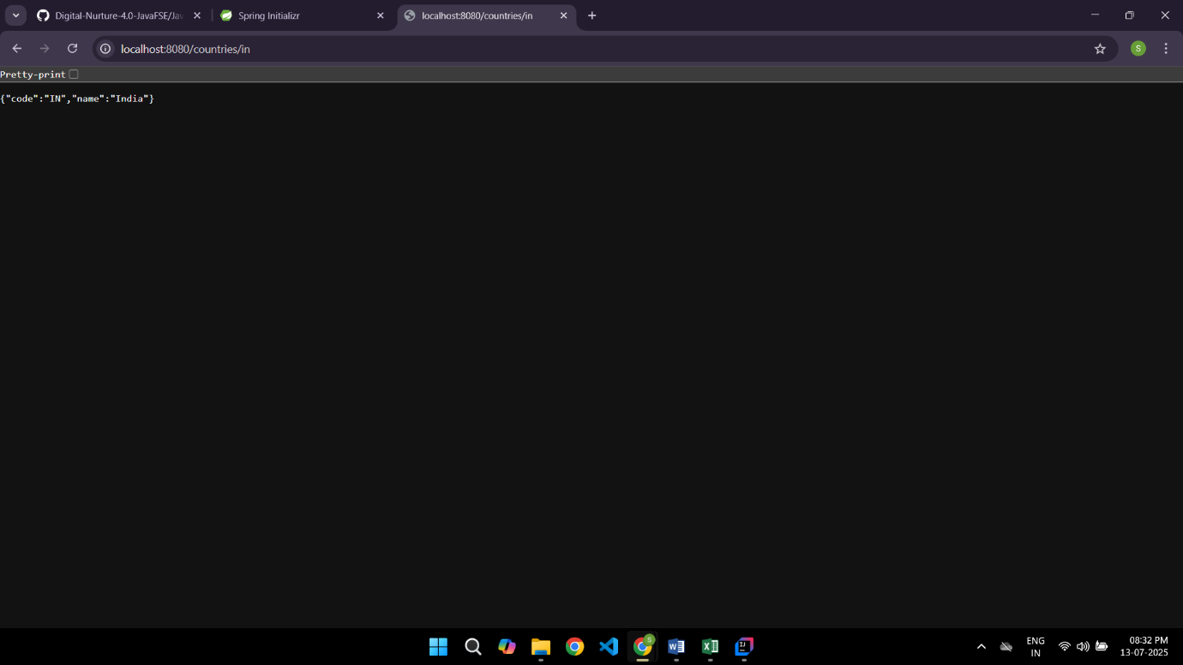

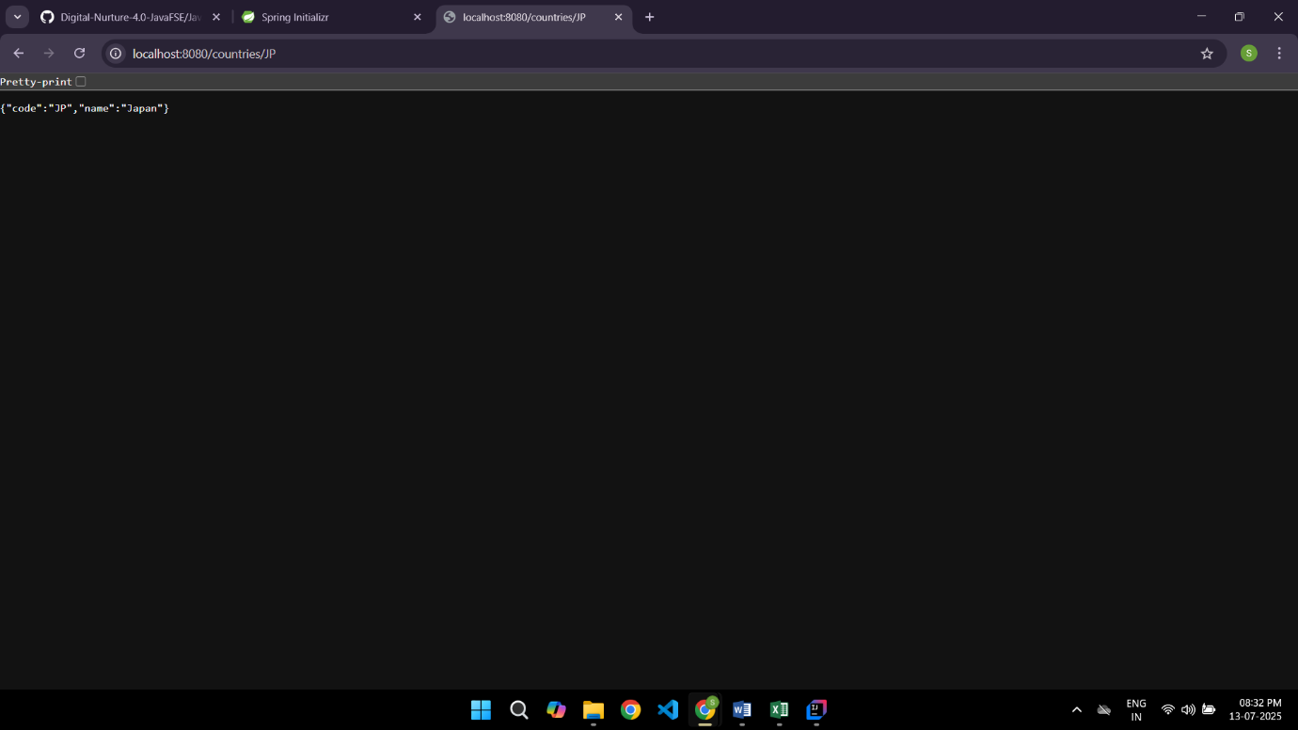

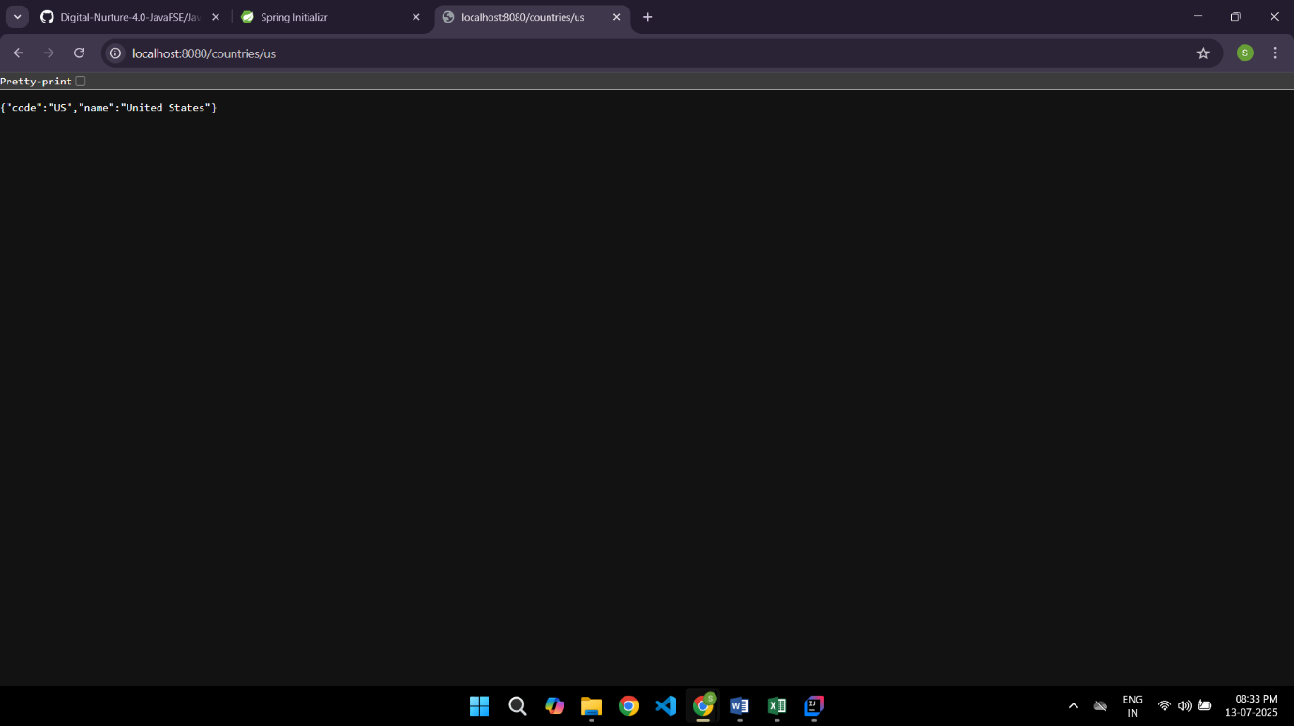

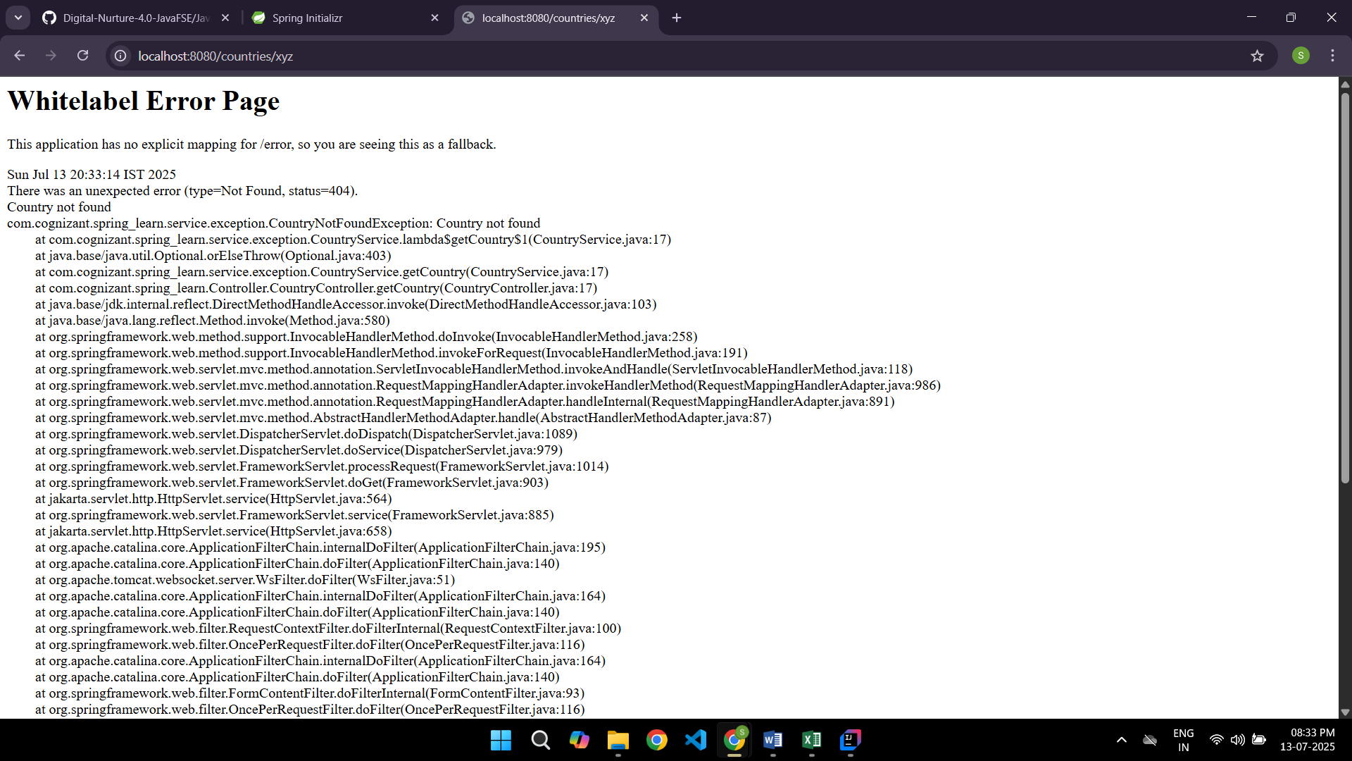

**Exercise 1: Hello World RESTful WEB Service**

**HelloController.java**

package com.cognizant.spring_learn.Controller;

import org.slf4j.Logger;

import org.slf4j.LoggerFactory;

import org.springframework.web.bind.annotation.GetMapping;

import org.springframework.web.bind.annotation.RestController;

@RestController

public class HelloController {

private static final Logger LOGGER = LoggerFactory.getLogger(HelloController.class);

@GetMapping("/hello")

public String sayHello() {

LOGGER.info("START");

LOGGER.info("END");

return "Hello World!!";

}

}

**SpringLearnApplication.java**

package com.cognizant.spring_learn;

import org.springframework.boot.SpringApplication;

import org.springframework.boot.autoconfigure.SpringBootApplication;

@SpringBootApplication

public class SpringLearnApplication {

public static void main(String[] args) {

SpringApplication.run(SpringLearnApplication.class, args);

}

}

**OUTPUT:**

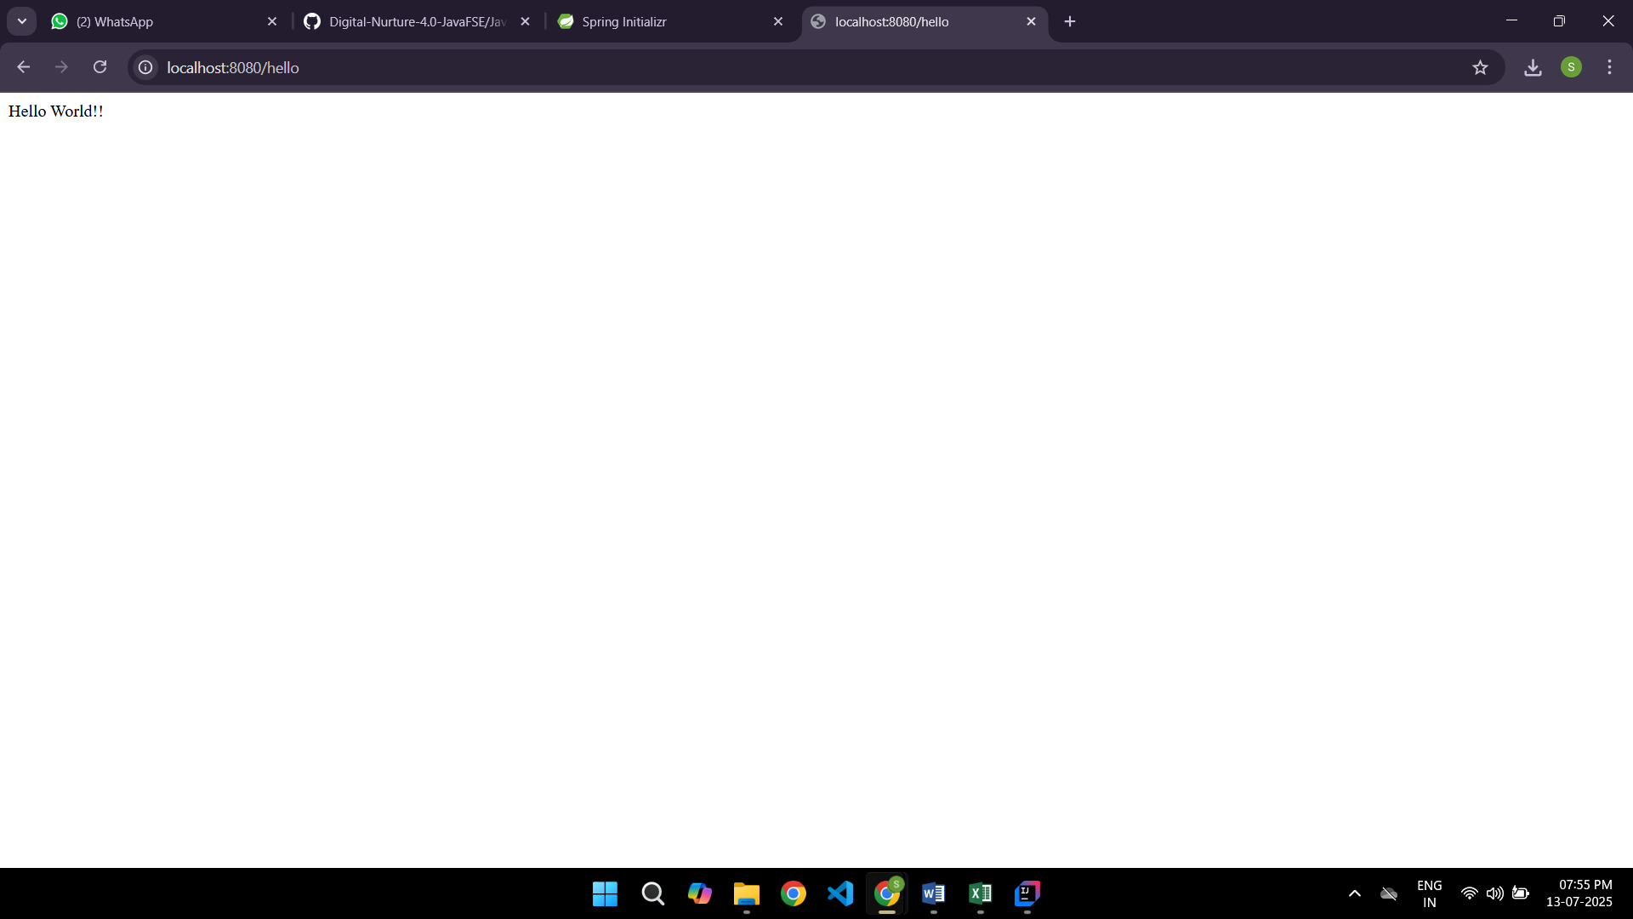

**Exercise 2: REST- Country Web Service**

**Country.xml**

<?xml version="1.0" encoding="UTF-8"?>

<beans xmlns="http://www.springframework.org/schema/beans"

xmlns:xsi="http://www.w3.org/2001/XMLSchema-instance"

xsi:schemaLocation="

http://www.springframework.org/schema/beans

https://www.springframework.org/schema/beans/spring-beans.xsd">

<bean id="in" class="com.cognizant.spring_learn.model.Country">

<property name="code" value="IN"/>

<property name="name" value="India"/>

</bean>

</beans>

**Country.java**

package com.cognizant.spring_learn.model;

public class Country {

private String code;

private String name;

public String getCode() {

return code;

}

public void setCode(String code) {

this.code = code;

}

public String getName() {

return name;

}

public void setName(String name) {

this.name = name;

}

}

**CountryController.java**

package com.cognizant.spring_learn.Controller;

import com.cognizant.spring_learn.model.Country;

import org.springframework.beans.factory.annotation.Autowired;

import org.springframework.context.ApplicationContext;

import org.springframework.web.bind.annotation.RequestMapping;

import org.springframework.web.bind.annotation.RestController;

@RestController

public class CountryController {

@Autowired

private ApplicationContext context;

@RequestMapping("/country")

public Country getCountryIndia() {

return (Country) context.getBean("in");

}

}

**SpringLearnApplication.java**

package com.cognizant.spring_learn;

import org.springframework.boot.SpringApplication;

import org.springframework.boot.autoconfigure.SpringBootApplication;

import org.springframework.context.annotation.ImportResource;

@SpringBootApplication

@ImportResource("classpath:country.xml")

public class SpringLearnApplication {

public static void main(String[] args) {

SpringApplication.run(SpringLearnApplication.class, args);

}

}

**OUTPUT:**

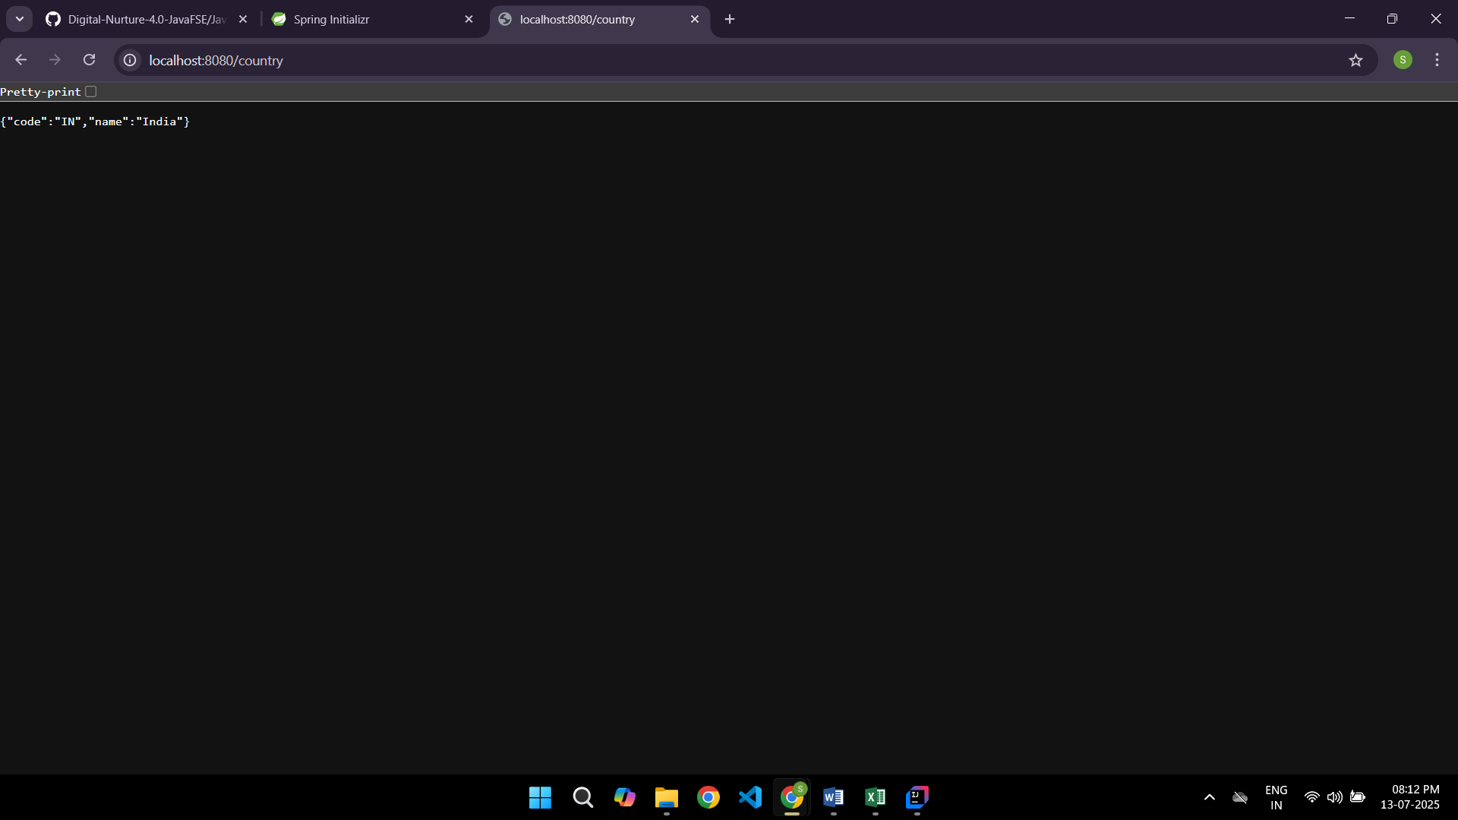

**Exercise 2: Spring Core Load Country From Spring Configuration XML**

**pom.xml**

<?xml version="1.0" encoding="UTF-8"?>

<project xmlns="http://maven.apache.org/POM/4.0.0" xmlns:xsi="http://www.w3.org/2001/XMLSchema-instance"

xsi:schemaLocation="http://maven.apache.org/POM/4.0.0 https://maven.apache.org/xsd/maven-4.0.0.xsd">

<modelVersion>4.0.0</modelVersion>

<parent>

<groupId>org.springframework.boot</groupId>

<artifactId>spring-boot-starter-parent</artifactId>

<version>3.5.3</version>

<relativePath/> <!-- lookup parent from repository -->

</parent>

<groupId>com.cognizant</groupId>

<artifactId>spring-learn</artifactId>

<version>0.0.1-SNAPSHOT</version>

<name>spring-learn</name>

<description>Demo project for Spring Boot</description>

<url/>

<licenses>

<license/>

</licenses>

<developers>

<developer/>

</developers>

<scm>

<connection/>

<developerConnection/>

<tag/>

<url/>

</scm>

<properties>

<java.version>17</java.version>

</properties>

<dependencies>

<dependency>

<groupId>org.springframework.boot</groupId>

<artifactId>spring-boot-starter-web</artifactId>

</dependency>

<dependency>

<groupId>org.springframework.boot</groupId>

<artifactId>spring-boot-devtools</artifactId>

<scope>runtime</scope>

<optional>true</optional>

</dependency>

<dependency>

<groupId>org.springframework.boot</groupId>

<artifactId>spring-boot-starter-test</artifactId>

<scope>test</scope>

</dependency>

</dependencies>

<build>

<plugins>

<plugin>

<groupId>org.springframework.boot</groupId>

<artifactId>spring-boot-maven-plugin</artifactId>

</plugin>

</plugins>

</build>

</project>

**country.xml**

<?xml version="1.0" encoding="UTF-8"?>

<beans xmlns="http://www.springframework.org/schema/beans"

xmlns:xsi="http://www.w3.org/2001/XMLSchema-instance"

xsi:schemaLocation="http://www.springframework.org/schema/beans

https://www.springframework.org/schema/beans/spring-beans.xsd">

<bean id="country" class="com.cognizant.spring_learn.Country">

<property name="code" value="IN" />

<property name="name" value="India" />

</bean>

</beans>

**Country.java**

package com.cognizant.spring_learn;

import org.slf4j.Logger;

import org.slf4j.LoggerFactory;

public class Country {

private static final Logger LOGGER = LoggerFactory.getLogger(Country.class);

private String code;

private String name;

public Country() {

LOGGER.debug("Inside Country Constructor");

}

public String getCode() {

LOGGER.debug("Getting code: {}", code);

return code;

}

public void setCode(String code) {

LOGGER.debug("Setting code: {}", code);

this.code = code;

}

public String getName() {

LOGGER.debug("Getting name: {}", name);

return name;

}

public void setName(String name) {

LOGGER.debug("Setting name: {}", name);

this.name = name;

}

@Override

public String toString() {

return "Country [code=" + code + ", name=" + name + "]";

}

}

**SpringLearnApplication.java**

package com.cognizant.spring_learn;

import org.slf4j.Logger;

import org.slf4j.LoggerFactory;

import org.springframework.context.ApplicationContext;

import org.springframework.context.support.ClassPathXmlApplicationContext;

public class SpringLearnApplication {

private static final Logger LOGGER = LoggerFactory.getLogger(SpringLearnApplication.class);

public static void main(String[] args) {

SpringLearnApplication app = new SpringLearnApplication();

app.displayCountry();

}

public void displayCountry() {

LOGGER.info("START");

ApplicationContext context = new ClassPathXmlApplicationContext("country.xml");

Country country = context.getBean("country", Country.class);

LOGGER.debug("Country : {}", country.toString());

LOGGER.info("END");

}

}

**OUTPUT:**

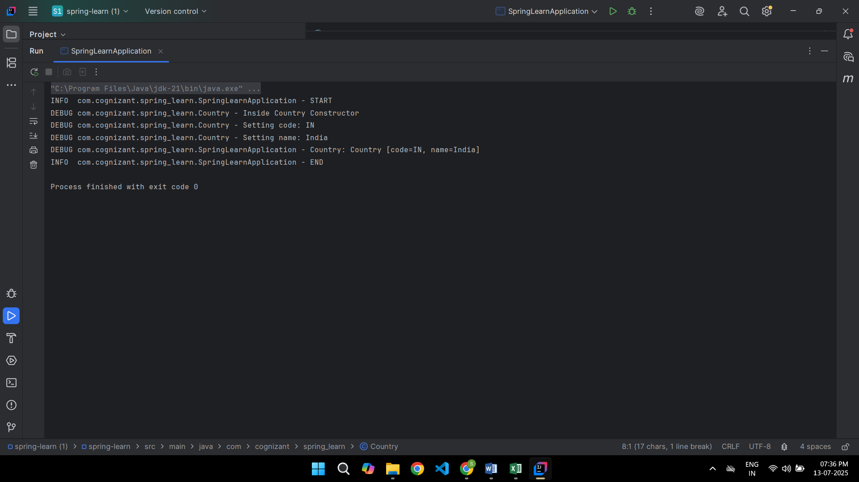

**Create Authentication Service that returns JWT**

**CountryConfig.java:**

package com.cognizant.spring_learn.config;

import com.cognizant.spring_learn.model.Country;

import org.springframework.context.annotation.Bean;

import org.springframework.context.annotation.Configuration;

import java.util.Arrays;

import java.util.List;

@Configuration

public class CountryConfig {

@Bean

public List<Country> countryList() {

return Arrays.asList(

new Country("IN", "India"),

new Country("US", "United States"),

new Country("JP", "Japan")

);

}

}

**SecurityConfig.java**

package com.cognizant.spring_learn.security;

import org.slf4j.Logger;

import org.slf4j.LoggerFactory;

import org.springframework.context.annotation.Bean;

import org.springframework.context.annotation.Configuration;

import org.springframework.security.authentication.AuthenticationManager;

import org.springframework.security.config.annotation.authentication.builders.AuthenticationManagerBuilder;

import org.springframework.security.config.annotation.web.builders.HttpSecurity;

import org.springframework.security.config.annotation.web.configuration.EnableWebSecurity;

import org.springframework.security.config.annotation.web.configuration.WebSecurityConfigurerAdapter;

import org.springframework.security.crypto.bcrypt.BCryptPasswordEncoder;

import org.springframework.security.crypto.password.PasswordEncoder;

@Configuration

@EnableWebSecurity

public class SecurityConfig extends WebSecurityConfigurerAdapter {

private static final Logger LOGGER = LoggerFactory.getLogger(SecurityConfig.class);

@Override

protected void configure(AuthenticationManagerBuilder auth) throws Exception {

auth.inMemoryAuthentication()

.withUser("admin").password(passwordEncoder().encode("pwd")).roles("ADMIN")

.and()

.withUser("user").password(passwordEncoder().encode("pwd")).roles("USER");

}

@Bean

public PasswordEncoder passwordEncoder() {

return new BCryptPasswordEncoder();

}

@Override

protected void configure(HttpSecurity httpSecurity) throws Exception {

httpSecurity.csrf().disable().httpBasic().and()

.authorizeRequests()

.antMatchers("/authenticate").hasAnyRole("USER", "ADMIN")

.anyRequest().authenticated()

.and()

.addFilter(new JwtAuthorizationFilter(authenticationManager()));

}

@Override

@Bean

public AuthenticationManager authenticationManagerBean() throws Exception {

return super.authenticationManagerBean();

}

}

**JwtAuthorizationFilter.java**

package com.cognizant.spring_learn.security;

import java.io.IOException;

import java.util.ArrayList;

import javax.servlet.FilterChain;

import javax.servlet.ServletException;

import javax.servlet.http.HttpServletRequest;

import javax.servlet.http.HttpServletResponse;

import org.slf4j.Logger;

import org.slf4j.LoggerFactory;

import org.springframework.security.authentication.AuthenticationManager;

import org.springframework.security.authentication.UsernamePasswordAuthenticationToken;

import org.springframework.security.core.context.SecurityContextHolder;

import org.springframework.security.web.authentication.www.BasicAuthenticationFilter;

import io.jsonwebtoken.Claims;

import io.jsonwebtoken.Jws;

import io.jsonwebtoken.JwtException;

import io.jsonwebtoken.Jwts;

public class JwtAuthorizationFilter extends BasicAuthenticationFilter {

private static final Logger LOGGER = LoggerFactory.getLogger(JwtAuthorizationFilter.class);

public JwtAuthorizationFilter(AuthenticationManager authManager) {

super(authManager);

}

@Override

protected void doFilterInternal(HttpServletRequest req, HttpServletResponse res,

FilterChain chain) throws IOException, ServletException {

LOGGER.info("Start JWT filter");

String header = req.getHeader("Authorization");

LOGGER.debug("JWT Header: {}", header);

if (header == null || !header.startsWith("Bearer ")) {

chain.doFilter(req, res);

return;

}

UsernamePasswordAuthenticationToken auth = getAuthentication(req);

SecurityContextHolder.getContext().setAuthentication(auth);

chain.doFilter(req, res);

}

private UsernamePasswordAuthenticationToken getAuthentication(HttpServletRequest request) {

String token = request.getHeader("Authorization");

if (token != null) {

try {

Jws<Claims> jws = Jwts.parser()

.setSigningKey("secretkey")

.parseClaimsJws(token.replace("Bearer ", ""));

String user = jws.getBody().getSubject();

if (user != null) {

return new UsernamePasswordAuthenticationToken(user, null, new ArrayList<>());

}

} catch (JwtException e) {

LOGGER.error("Invalid token", e);

}

}

return null;

}

}

**pom.xml**

<project xmlns="http://maven.apache.org/POM/4.0.0"

xmlns:xsi="http://www.w3.org/2001/XMLSchema-instance"

xsi:schemaLocation="http://maven.apache.org/POM/4.0.0 http://maven.apache.org/xsd/maven-4.0.0.xsd">

<modelVersion>4.0.0</modelVersion>

<groupId>com.cognizant</groupId>

<artifactId>spring-learn</artifactId>

<version>1.0.0</version>

<packaging>jar</packaging>

<name>spring-learn</name>

<parent>

<groupId>org.springframework.boot</groupId>

<artifactId>spring-boot-starter-parent</artifactId>

<version>2.7.18</version>

<relativePath/>

</parent>

<properties>

<java.version>1.8</java.version> <!-- or 11 if you're using Java 11 -->

</properties>

<dependencies>

<dependency>

<groupId>org.springframework.boot</groupId>

<artifactId>spring-boot-starter-web</artifactId>

</dependency>

<dependency>

<groupId>org.springframework.boot</groupId>

<artifactId>spring-boot-starter-security</artifactId>

</dependency>

<dependency>

<groupId>io.jsonwebtoken</groupId>

<artifactId>jjwt</artifactId>

<version>0.9.0</version>

</dependency>

<dependency>

<groupId>javax.servlet</groupId>

<artifactId>javax.servlet-api</artifactId>

<version>4.0.1</version>

<scope>provided</scope>

</dependency>

<dependency>

<groupId>org.springframework.boot</groupId>

<artifactId>spring-boot-starter-logging</artifactId>

</dependency>

<dependency>

<groupId>org.projectlombok</groupId>

<artifactId>lombok</artifactId>

<optional>true</optional>

</dependency>

<dependency>

<groupId>org.springframework.boot</groupId>

<artifactId>spring-boot-devtools</artifactId>

<scope>runtime</scope>

</dependency>

<dependency>

<groupId>org.springframework.boot</groupId>

<artifactId>spring-boot-starter-test</artifactId>

<scope>test</scope>

</dependency>

<dependency>

<groupId>javax.xml.bind</groupId>

<artifactId>jaxb-api</artifactId>

<version>2.3.1</version>

</dependency>

</dependencies>

<build>

<plugins>

<plugin>

<groupId>org.springframework.boot</groupId>

<artifactId>spring-boot-maven-plugin</artifactId>

</plugin>

</plugins>

</build>

</project>

**Country.java**

package com.cognizant.spring_learn.model;

public class Country {

private String code;

private String name;

public String getCode() {

return code;

}

public void setCode(String code) {

this.code = code;

}

public String getName() {

return name;

}

public void setName(String name) {

this.name = name;

}

}

**CountryController.java**

package com.cognizant.spring_learn.Controller;

import com.cognizant.spring_learn.model.Country;

import com.cognizant.spring_learn.service.exception.CountryService;

import org.springframework.beans.factory.annotation.Autowired;

import org.springframework.web.bind.annotation.*;

import java.util.List;

@RestController

public class CountryController {

@Autowired

private CountryService countryService;

@GetMapping("/countries")

public List<Country> getAllCountries() {

return countryService.getAllCountries();

}

@GetMapping("/countries/{code}")

public Country getCountry(@PathVariable String code) throws Exception {

return countryService.getCountry(code);

}

}

**CountryService.java**

package com.cognizant.spring_learn.service.exception;

import com.cognizant.spring_learn.model.Country;

import org.springframework.stereotype.Service;

import java.util.Arrays;

import java.util.List;

@Service

public class CountryService {

public List<Country> getAllCountries() {

return Arrays.asList(

new Country("IN", "India"),

new Country("US", "United States"),

new Country("JP", "Japan")

);

}

public Country getCountry(String code) throws Exception {

return getAllCountries().stream()

.filter(c -> c.getCode().equalsIgnoreCase(code))

.findFirst()

.orElseThrow(() -> new Exception("Country not found: " + code));

}

}

**AuthenticationController.java**

package com.cognizant.spring_learn.Controller;

import java.util.Base64;

import java.util.Date;

import java.util.HashMap;

import java.util.Map;

import org.slf4j.Logger;

import org.slf4j.LoggerFactory;

import org.springframework.web.bind.annotation.GetMapping;

import org.springframework.web.bind.annotation.RequestHeader;

import org.springframework.web.bind.annotation.RestController;

import io.jsonwebtoken.JwtBuilder;

import io.jsonwebtoken.Jwts;

import io.jsonwebtoken.SignatureAlgorithm;

@RestController

public class AuthenticationController {

private static final Logger LOGGER = LoggerFactory.getLogger(AuthenticationController.class);

@GetMapping("/authenticate")

public Map<String, String> authenticate(@RequestHeader("Authorization") String authHeader) {

LOGGER.info("Start authentication");

LOGGER.debug("Header: {}", authHeader);

String user = getUser(authHeader);

String token = generateJwt(user);

Map<String, String> map = new HashMap<>();

map.put("token", token);

LOGGER.info("End authentication");

return map;

}

private String getUser(String authHeader) {

String encoded = authHeader.substring("Basic ".length());

byte[] decodedBytes = Base64.getDecoder().decode(encoded);

String decoded = new String(decodedBytes);

return decoded.split(":")[0];

}

private String generateJwt(String user) {

JwtBuilder builder = Jwts.builder();

builder.setSubject(user);

builder.setIssuedAt(new Date());

builder.setExpiration(new Date(System.currentTimeMillis() + 1200000)); // 20 minutes

builder.signWith(SignatureAlgorithm.HS256, "secretkey");

return builder.compact();

}

}

**SpringLearnApplication.java**

package com.cognizant.spring_learn;

import org.springframework.boot.SpringApplication;

import org.springframework.boot.autoconfigure.SpringBootApplication;

@SpringBootApplication

public class SpringLearnApplication {

public static void main(String[] args) {

SpringApplication.run(SpringLearnApplication.class, args);

}

}

**OUTPUT:**

